**14. Deployment Architecture for Speech-to-Text Converter Application**

**14.1.Overview**

The deployment architecture of the Speech-to-Text Converter application is designed to ensure scalability, high availability, and security. The application is hosted on a cloud platform (e.g., Microsoft Azure) and follows a microservices architecture pattern, where different components of the application are deployed as independent services. This architecture allows for efficient resource utilization and easier maintenance and updates.

**14.2. Components**

1. **Frontend (User Interface)**
   * **Technology**: Tkinter (Python)
   * **Purpose**: Provides the graphical user interface for users to interact with the application.
   * **Deployment**: Packaged as a standalone application or a desktop client.
2. **Backend (Application Logic)**
   * **Technology**: Python (Flask/Django)
   * **Purpose**: Handles business logic, processes user requests, and interacts with the database.
   * **Deployment**: Deployed as a set of microservices on Azure App Service or Azure Kubernetes Service (AKS).
3. **Speech Recognition Service**
   * **Technology**: Google Speech Recognition API
   * **Purpose**: Transcribes spoken words into text.
   * **Deployment**: Accessed via API calls from the backend.
4. **Database**
   * **Technology**: Azure SQL Database or MongoDB (hosted on Azure Cosmos DB)
   * **Purpose**: Stores transcribed text data, user settings, and application logs.
   * **Deployment**: Hosted on Azure.
5. **Authentication and Authorization**
   * **Technology**: Azure Active Directory
   * **Purpose**: Manages user authentication and access control.
   * **Deployment**: Integrated with the backend services.
6. **Storage**
   * **Technology**: Azure Blob Storage
   * **Purpose**: Stores audio files and other large data objects.
   * **Deployment**: Managed by Azure.
7. **Monitoring and Logging**
   * **Technology**: Azure Monitor, Azure Log Analytics
   * **Purpose**: Monitors application performance, logs errors, and provides analytics.
   * **Deployment**: Integrated with all backend services.

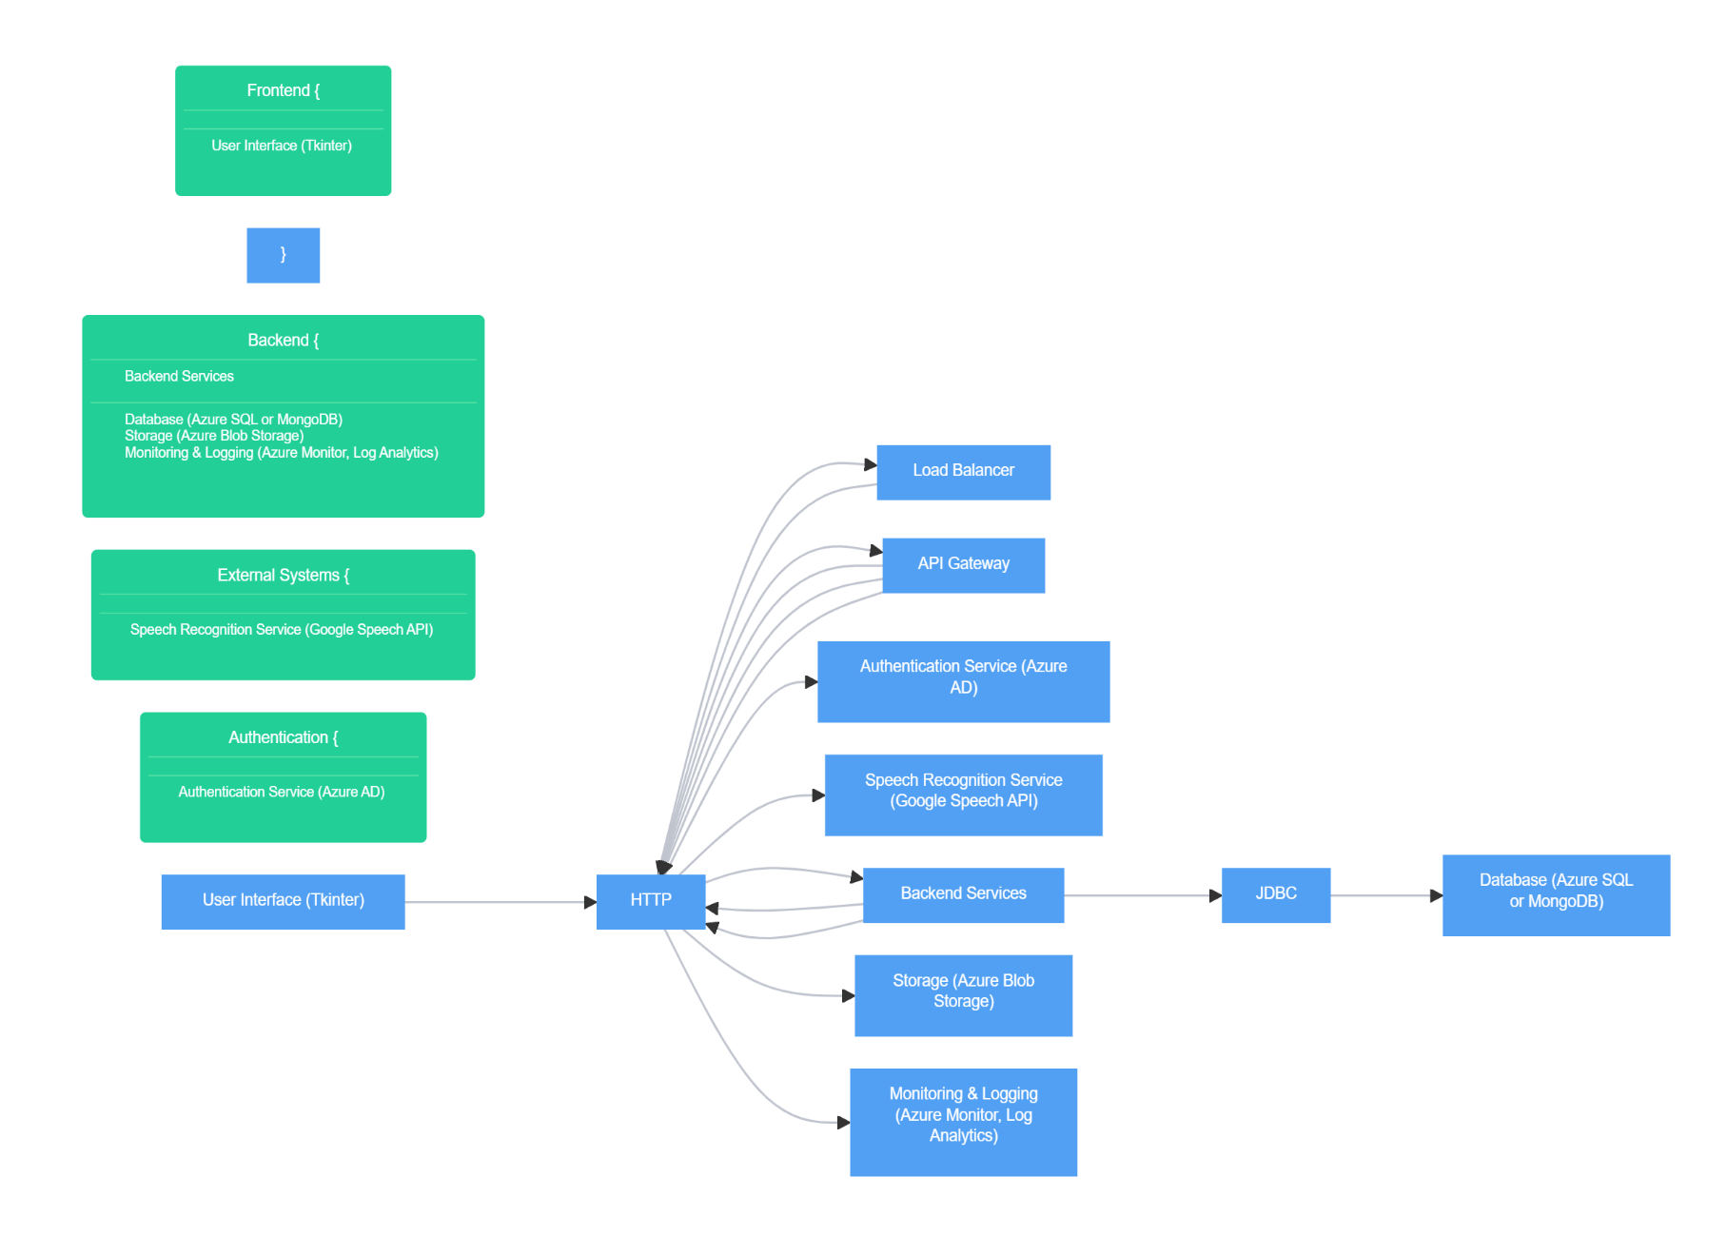**14.3. Deployment Architecture Diagram**

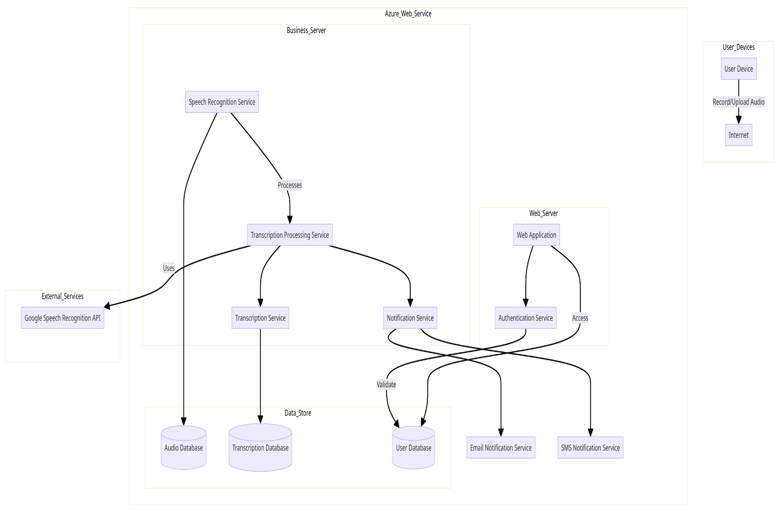

**14.4. Detailed Components Description**

1. **User Interface (Tkinter)**
   * **Description**: The Tkinter-based desktop application serves as the front end for users. It provides features like starting/stopping recordings, viewing real-time transcriptions, and adjusting settings.
   * **Deployment**: The Tkinter application is packaged as a standalone executable and can be distributed to end-users.
2. **Load Balancer**
   * **Description**: Distributes incoming HTTP requests across multiple backend service instances to ensure high availability and fault tolerance.
   * **Deployment**: Managed by Azure Load Balancer or Azure Application Gateway.
3. **API Gateway**
   * **Description**: Acts as a single entry point for all client requests, routing them to the appropriate backend services. It also handles authentication, rate limiting, and request/response transformation.
   * **Deployment**: Deployed using Azure API Management.
4. **Authentication Service (Azure AD)**
   * **Description**: Manages user authentication and provides secure access to the application. It integrates with the backend services to enforce access control.
   * **Deployment**: Managed by Azure Active Directory.
5. **Speech Recognition Service (Google Speech API)**
   * **Description**: Provides speech-to-text conversion capabilities. The backend services send audio data to the Google Speech API and receive transcribed text in return.
   * **Deployment**: Accessed as an external API.
6. **Backend Services**
   * **Description**: The core application logic, implemented using Flask or Django, handles user requests, processes audio data, and interacts with other services (database, storage, etc.).
   * **Deployment**: Deployed as microservices on Azure App Service or Azure Kubernetes Service (AKS).
7. **Database (Azure SQL or MongoDB)**
   * **Description**: Stores all transcribed text data, user settings, and logs. Provides data persistence and query capabilities.
   * **Deployment**: Hosted on Azure SQL Database or Azure Cosmos DB for MongoDB.
8. **Storage (Azure Blob Storage)**
   * **Description**: Stores large data objects such as audio files. Provides scalable and secure storage solutions.
   * **Deployment**: Managed by Azure Blob Storage.
9. **Monitoring & Logging (Azure Monitor, Log Analytics)**
   * **Description**: Monitors application performance and logs errors and other significant events. Provides insights and analytics to help with troubleshooting and optimization.
   * **Deployment**: Integrated with all backend services and managed by Azure Monitor and Azure Log Analytics.

**14.5. Conclusion**

The deployment architecture for the Speech-to-Text Converter application is designed to ensure that the application is scalable, reliable, and secure. By leveraging Azure services, the architecture provides a robust environment for deploying and managing the application, allowing it to handle varying loads and provide a seamless experience to users.